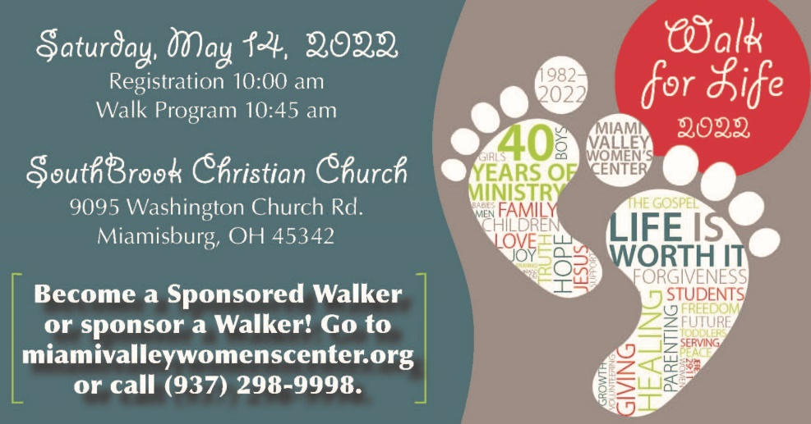
SAMPLE EMAILS/TEXTS
These can be cut and pasted into individual emails or texts to friends and family. It can also be used as “Your Welcome Message” on your FundEasy page.

INTRODUCTION for NEW sponsors
Suggested subject line: Will you help me raise funds to save unborn lives?
Dear ___________________________,
On May 14, I am participating as a Sponsored Walker for the Miami Valley Women’s Center (MVWC) Walk for Life. The MVWC is a local pregnancy resource center that gives help and hope for women, men, and students facing a crisis pregnancy. They provide all services and programs at NO cost! Why? In 2020, over 20,600 unborn lives were ended in Ohio, 2,770 in Montgomery County alone (OH Dept. of Health, 2020). Since 1982, the MVWC has helped over 15,000 clients choose life for their unborn babies!
My goal is (fill in), and I am participating because (fill in with your personal reason). Would you support me and this ministry by sponsoring me in the Walk for Life?

INTRODUCTION for PAST sponsors
Suggested subject line: Will you sponsor me again for this year’s Walk for Life?
Hi ,
The Miami Valley Women’s Center’s (MVWC) Walk for Life is just around the corner and once again I will be participating as a Sponsored Walker. This year’s Walk goal is $275,000 which will help support the free, compassionate services they provide for women, men, and students in an unplanned pregnancy. The latest statistics show that 2,770 unborn babies were aborted in Montgomery County in 2020 and over 20,600 throughout Ohio (OH Dept. of Health, 2020). However, since 1982, the MVWC has served over 15,000 clients who chose life for their unborn babies! Would you support me and this ministry by sponsoring me again?
My goal is (fill in), and I am participating because (fill in with your personal reason).

REMAINDER of email for past AND new sponsors
Funds I raise directly support programs and services provided at NO COST to the client. To learn more, visit their website at https://miamivalleywomenscenter.org/about-us/services-programs/. Please consider sponsoring me for $25, $50, $100 or whatever the Lord leads you to give to help me reach my goal. You can pay me ahead of time with cash or check (made out to the MVWC).
If you are using FundEasy, share how they can sponsor you online:
You can also see how I am doing and sponsor me online. Go to miamivalleywomenscenter.org, click on Walk for Life, then click the box that says Sponsor a Walker.
Please reply to this e-mail (or let me know if you’ll sponsor me on FundEasy) with your complete address, sponsorship amount, and payment method. Gifts are tax deductible and receipts will be mailed for gifts of $25 or more, unless specifically requested.
Thank you for your support and helping us save unborn lives and spread hope to our community!

