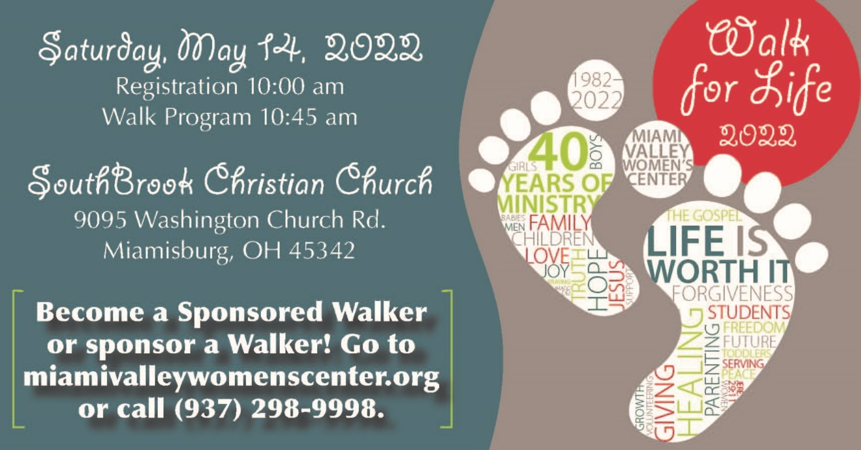

Suggestions for Promoting the Walk for Life at Church

Ideal
    - Pastor or Liaison promotes the Walk for Life from the pulpit and participates in the Walk on May 14.

    - Show the Walk promo video during church services beginning in April through May 8.

    - Pastor or Liaison speaks to congregation, Sunday School classes, or other small groups to encourage participation.

    - Add the Walk for Life PowerPoint slide to the church website and announcement loop before each service beginning in April.

    - Beginning in April, set up a table in the lobby with a t-shirt, poster, FundEasy cards, etc. Liaison attends to the table to encourage others to become a Sponsored Walker or sponsor one of your church’s Walkers.

    - Print and distribute the Walk bulletin inserts one Sunday in April.

    - Share Walk for Life Facebook posts on the church Facebook page and/or link users to the Walk for Life page on the MVWC website (miamivalleywomenscenter.org).

    - Run Walk announcements on the big screen, monitors, your bulletin or elsewhere, at least a month before the Walk.

    - Put up Walk posters in prominent places in your church building.
Good

