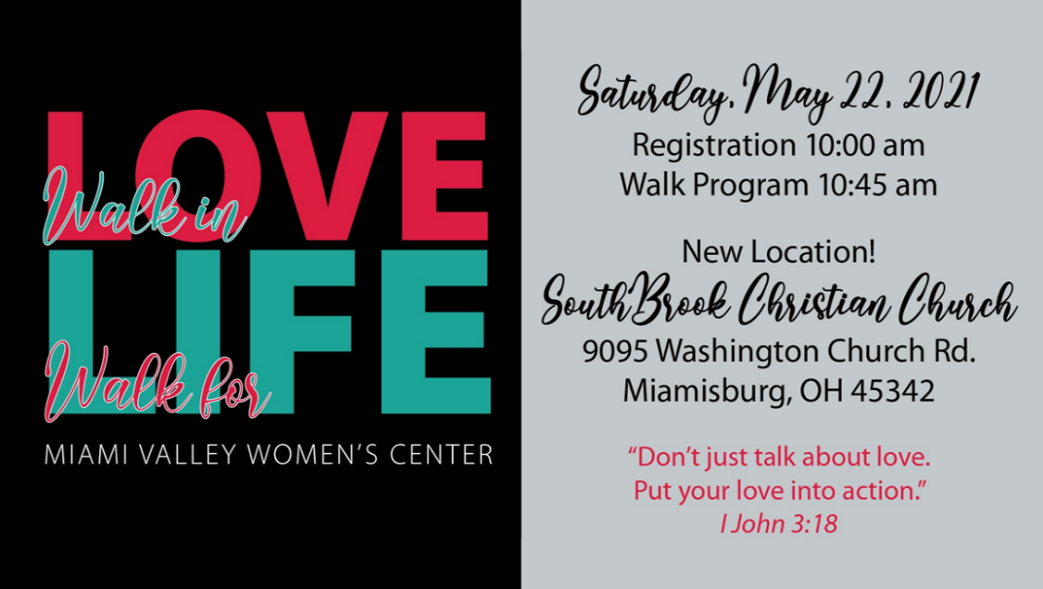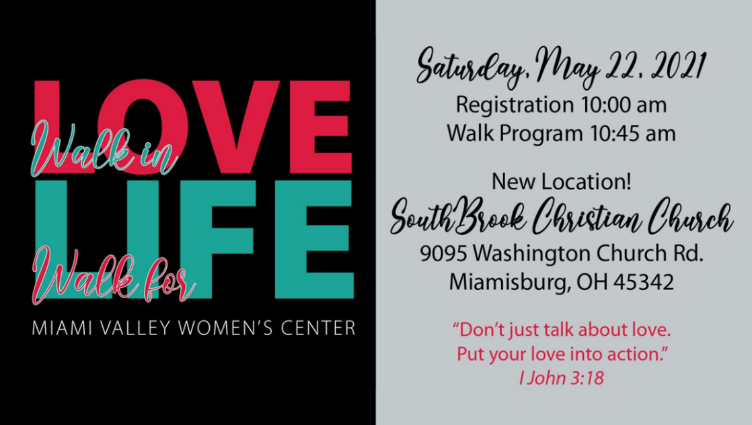

At the Miami Valley Women’s Center, we come alongside women, men, and students who are in a crisis and offer practical help at no cost: pregnancy services, material resources, incentive-based parenting classes, grief support, abortion recovery ministry, and much more! Every week at our four locations, we see dozens of women who think abortion is their only answer. By God’s grace and through the generosity of ministry partners, since 1982, we have helped over 15,000 women choose life for their unborn babies!

**Will you put feet to your pro-life beliefs and support the Walk for Life?** Every dollar raised will help us provide compassionate help to clients and share the hope of the gospel!

To learn how to raise funds as a Sponsored Walker or to sponsor a Walker, go to [*miamivalleywomenscenter.org*](miamivalleywomenscenter.org)*.* Those who *give or raise* $300 will receive a “LOVE LIFE” t-shirt! Payment methods are cash, check (MVWC), credit card, or we can send a bill for gifts of $25 and over.

**Let’s come together and show our LOVE for LIFE** on Saturday, May 22, at SouthBrook Christian Church. Following the 10:45 program, we’ll enjoy a 2-mile walk around the campus of Dayton Christian School (next to SouthBrook).

For more information, contact Jeni at [jeni.newman@womenscenter.org](mailto:jeni.newman@womenscenter.org). or call (937) 298-9998.

At the Miami Valley Women’s Center, we come alongside women, men, and students who are in a crisis and offer practical help at no cost: pregnancy services, material resources, incentive-based parenting classes, grief support, abortion recovery ministry, and much more! Every week at our four locations, we see dozens of women who think abortion is their only answer. By God’s grace and through the generosity of ministry partners, since 1982, we have helped over 15,000 women choose life for their unborn babies!

**Will you put feet to your pro-life beliefs and support the Walk for Life?** Every dollar raised will help us provide compassionate help to clients and share the hope of the gospel!

To learn how to raise funds as a Sponsored Walker or to sponsor a Walker, go to [*miamivalleywomenscenter.org*](miamivalleywomenscenter.org)*.* Those who *give or raise* $300 will receive a “LOVE LIFE” t-shirt! Payment methods are cash, check (MVWC), credit card, or we can send a bill for gifts of $25 and over.

**Let’s come together and show our LOVE for LIFE** on Saturday, May 22, at SouthBrook Christian Church. Following the 10:45 program, we’ll enjoy a 2-mile walk around the campus of Dayton Christian School (next to SouthBrook).

For more information, contact Jeni at [jeni.newman@womenscenter.org](mailto:jeni.newman@womenscenter.org). or call (937) 298-9998.